**Liferay Training**

**About Liferay Content Management**

Liferay is a Web Content Management System & Portal. You can use it to create, store, edit, and maintain documents and web content. Your Liferay site has a staging area where you make all your site updates prior to publishing the site live. We have a Liferay support site with “how to” documents for your use: <https://my.nps.edu/web/support>

**Staging Environment**

As a Site Webmaster, you received the URL to your staging site in an email from ITACS. The URL for your staging site will be structured as follows:<https://my.nps.edu/web/yourSiteName-staging/>

You must log in with your NPS account to view the site.

**Adding a new page to your site**

It is easy to add new top-level pages or child pages to your site. From the top menu in Liferay, choose **Admin>Pages**. From the next menu, select **“+ Add Page**”. You can also add a Child page in this same window – first select the desired Parent page, then choose **“+ Add Child Page**”.

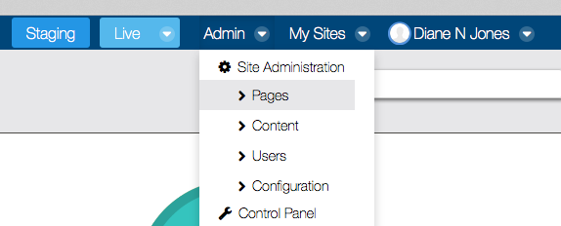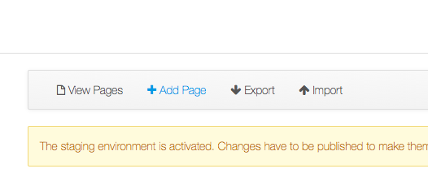

**Choose a page layout**

When you create a page, you can choose from several default layout options, as shown in the screenshot. You can also choose to link directly to an existing page, or external page. You can also create your own layouts by using “**Nested Portlet**” application with any default layout. To learn about **Nested Portlets**, view this tutorial on the support site: <https://my.nps.edu/web/support/-/nested-portlets>

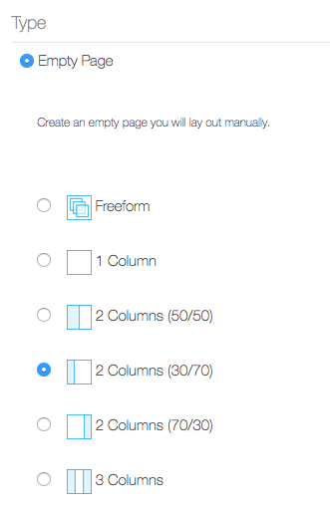

**Creating Web Content**

Steps to add new Web Content to your webpage  
<https://my.nps.edu/web/support/-/adding-web-content-from-page>

1. Click the "**Add" [+]** blue button from the left hand dock bar
2. Choose "**Application**"
3. Choose "**Web Content Display**"
4. Choose "**Select Web Content**" to select an existing Web Content Item or "**Add**" to create a new Web Content

We have built some custom content types or “**Structures**” for your use these include: **Slideshow, Tabs, Accordion, Video**. You can select your content type when you add Web Content to the Web Content Display**.**

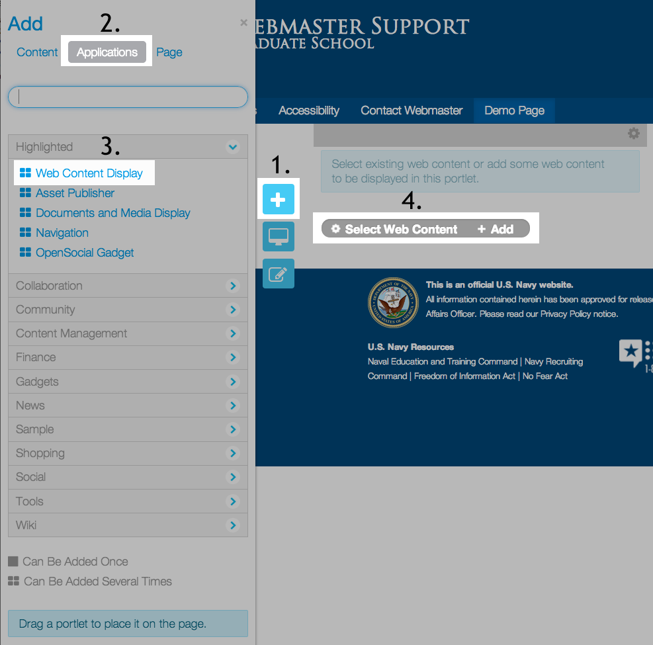

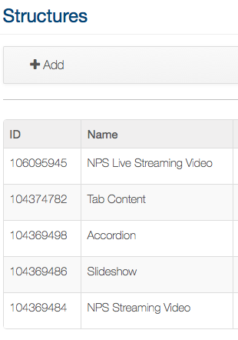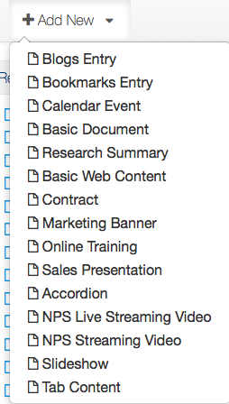

**Editing Web Content**

With the “**Edit Controls**” visible, you can select “**Edit**” from any content portal on your page and make content updates. Clicking edit will activate the WYSIWYG (what you see is what you get) editor, where you have options to add text, headings, images, tables etc. See following screenshots showing the edit controls.

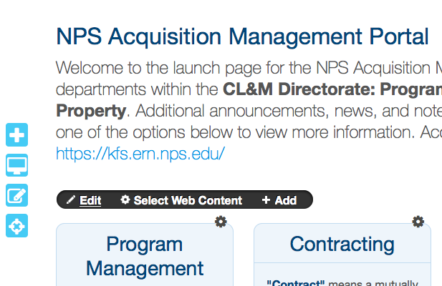

Edit Controls for web content areas – only visible in Staging site

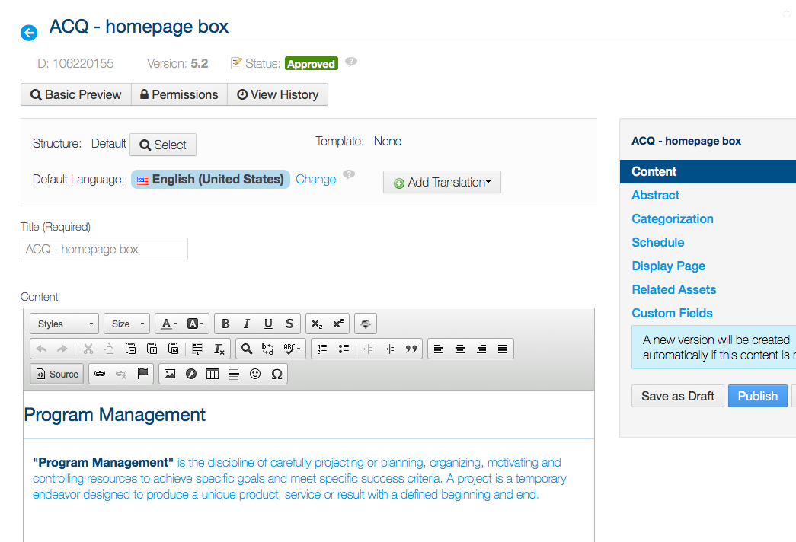

WYSIWYG editor

You must “Publish” to commit your changes

**How to UNDO after publishing Web Content**

Each piece of Web Content you create will have a **publish history**. After each publish, Liferay will save a new version (1.0, 1.1, 1.2, etc). You can always roll back to an earlier published version of your content if you do not like the changes you made. To do this you need to “**Expire**” the content piece you no longer want. You can also “**Copy**” Web Content to make a new independent version of existing content.

1). **Edit** the Web Content item you would like to roll back

2). Select the “**History**” button

3). Choose the last published version and choose “**Expire”** from the “**Actions**” drop-down.

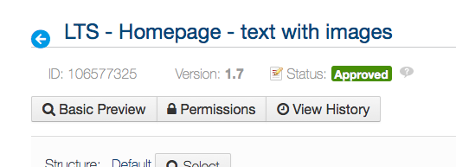

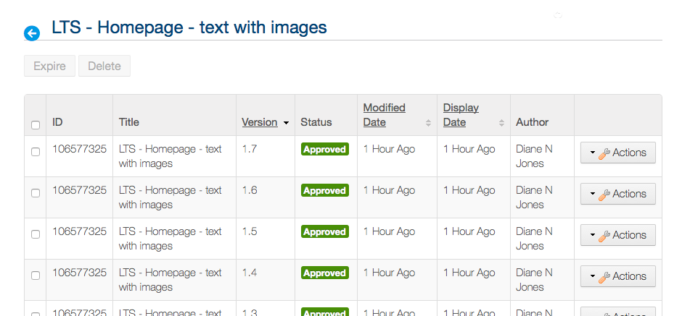

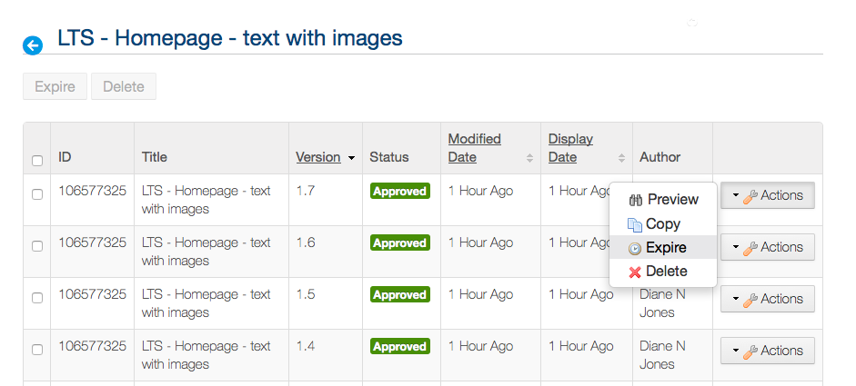

**Document Management: Uploading documents & images directly to folders**

To upload documents to a folder – access the “**Documents and Media**” section in the admin area of your staging site. Go to **Admin>Content>Documents and Media**

Navigate to a folder and select either **Add>Basic Document** or **Add>Multiple Documents.**

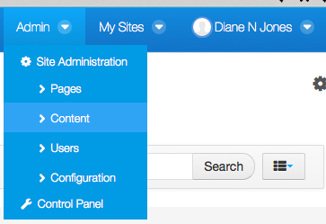

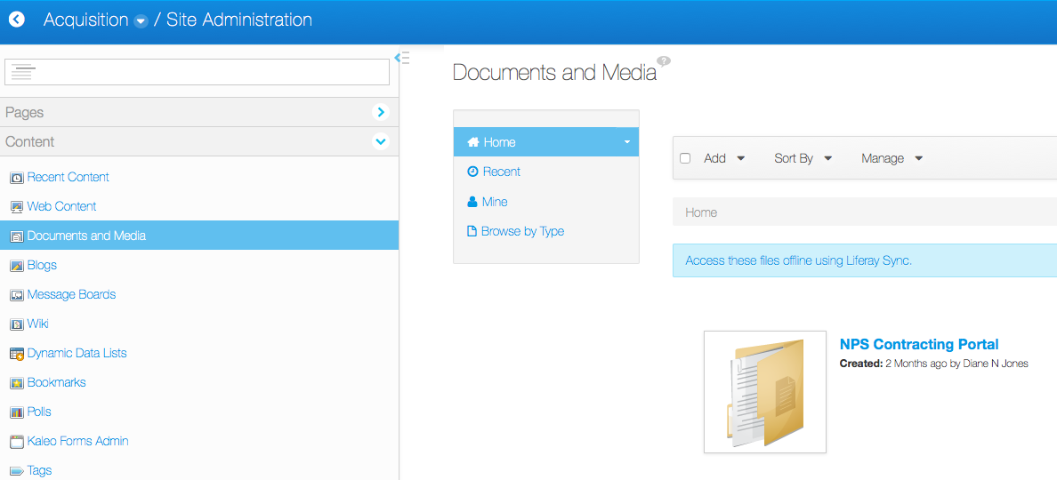

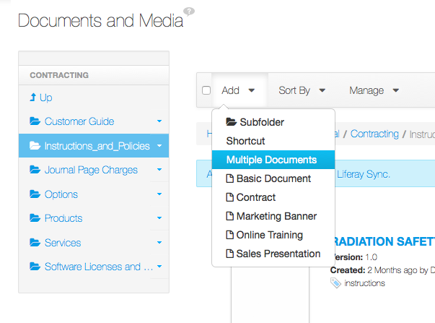

**Replace an existing document with your latest version**

To replace/overwrite an existing document, navigate to your document and select “**Edit”** from the drop down menu. From here you can select the “**Browse**” button and select the latest version of your document. This will upload and overwrite your current document. A new version will be created, so you can roll back as necessary.

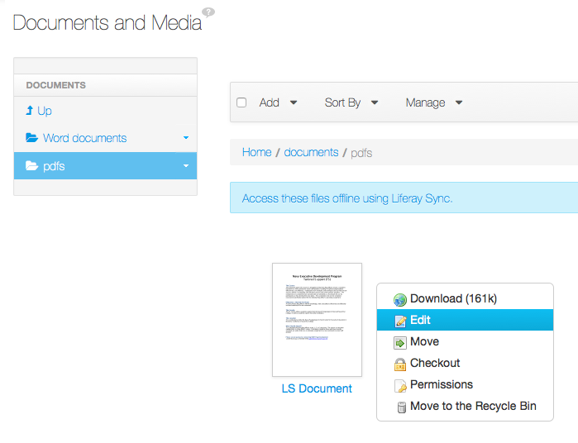

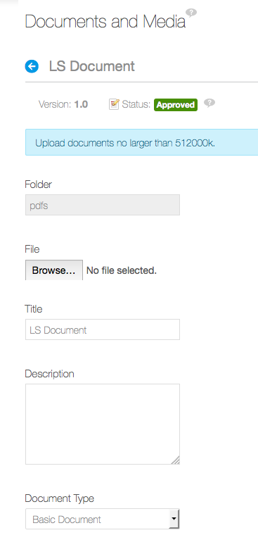

**Publishing the website to Live**

The site must be [published to live](https://my.nps.edu/web/support/-/video-publishing-a-page) (green button) to view it over the WWW. At the top menu bar, there is a button to publish.

URL format for a published **public** site:

<https://my.nps.edu/web/yourSiteName>

URL format for a published a **private** site: <https://my.nps.edu/group/yourSiteName>

